AI based dental intelligence System for automated detection and diagnosis of dental disease


Department of Computer Science

Rehan Mahmood Farooqi | NUM-BSCS-2022-49

2022-2026

Final year project report submitted in partial fulfillment of requirement for degree of Bachelors of Science in Computer Science

Namal University,
30-KM, Talagang Road, Mianwali, Pakistan.
www.namal.edu.pk

DECLARATION

The project report titled “AI based dental intelligence System for automated detection and diagnosis of dental disease” is submitted in partial fulfillment of the degree of Bachelors of Science in Computer Science, to the Department of Computer Science at Namal University, Mianwali, Pakistan.

It is declared that this is an original work done by the team members listed below, under the guidance of our supervisor “Mr. Ammar Ahmad”. No part of this project and its report is plagiarized from anywhere, and any help taken from previous work is cited properly.

No part of the work reported here is submitted in fulfillment of requirement for any other degree/ qualification in any institute of learning.

Team Members University ID Signatures

Rehan Mahmood Farooqi NUM-BSCS-2022-49 ____________________

Supervisor
Ammar Ahmad Khan

Signatures with date

__________________________

__________________________

Table of Contents
Contents
Abstract 8
Chapter 1 9
Introduction 9
1.1 Purpose 9
1.2 Scope 10
1.3 Definitions, Acronyms, and Abbreviations 10
1.4 References 10
1.5 Overview 11
Chapter 2 12
System Description 12
2.1 Overall Description 13
2.2 System Environment 13
2.3 Product Perspective 13
2.4 Product Features 13
Chapter 3 15
Analysis and Design 15
3.1 Functional Requirements 15
3.2 Non-Functional Requirements 16
3.3 System Models 17
3.3.1 Data Flow Diagrams (DFD) 17
3.3.1.1 Level 0 DFD: 17
3.3.1.2 Level 1 DFD: 17
3.3.2 Use Case Diagrams 18
3.3.3 ER Diagram 19
3.3.4 Sequence and Activity Diagrams 20
3.3.4.1 Sequence Diagram: 20
3.3.4.2 Activity Diagram: 21
3.4 External Interface Requirements 22
3.4.1 User Interfaces 22
3.4.2 Hardware Interfaces 23
3.4.3 Software Interfaces 23
3.4.4 Communication Interfaces 23
3.5 Constraints and Limitations 23
3.6 Assumptions and Dependencies 24
Chapter 4 25
Remaining Work and Timeline 25
4.1 Remaining Work 25
4.1.1 Training of Additional Deep Learning Models 25
4.1.2 Comparative Performance Analysis 25
4.1.3 Performance Optimization 25
4.1.4 System Testing and Validation 25
4.1.5 Results Documentation and Analysis 26
4.3 Milestone Overview 26
References 26

List of Figures
Figure 1: DFD Level 0 17
Figure 2: DFD Level 1 17
Figure 3: Use case diagrams 18
Figure 4: ER Diagram 19
Figure 5: System Sequence Diagrams 20
Figure 6: Activity Diagram 21
Figure 7: user interface 22

List of Tables
Table 1: Functional Requirements 15
Table 2: Remaining Tasks 26

Abstract
Oral health disorders remain a major public health concern worldwide, with a significant number of cases remaining undiagnosed or inaccurately diagnosed due to the reliance on manual interpretation of dental radiographic images, which is subjective, time-consuming, and dependent on expert availability. This work presents an Artificial Intelligence Based Dental Intelligence System, a production-ready and clinically oriented web-based platform developed to automate the detection and diagnosis of dental diseases from panoramic dental X-ray images. The proposed system introduces a multi-model consensus decision framework inspired by clinical board-based diagnosis, where multiple independent deep learning models collaboratively analyze radiographic data to improve diagnostic accuracy and reliability. Tooth localization is achieved using a real-time object detection model optimized for dental imaging, while disease classification is performed through an ensemble of three complementary deep learning architectures, including a vision transformer-based model, a residual convolutional neural network, and an efficient convolutional neural network. A severity-weighted majority decision strategy is employed to generate final diagnostic outcomes, ensuring that clinically critical conditions receive higher priority and reducing the risk of false-negative predictions. The system architecture is implemented using an asynchronous high-performance backend to enable real-time inference and scalability, complemented by a modern, clinically intuitive web-based user interface designed for professional use. In addition to diagnostic functionality for dental professionals, the system also includes administrative features for managing users, system configuration, and performance monitoring to ensure secure and reliable operation. Experimental evaluation conducted on annotated panoramic dental radiographic data demonstrates that the proposed ensemble-based framework achieves an overall diagnostic accuracy of 86.4 percent, outperforming individual model predictions and validating the effectiveness of consensus-driven inference. The results indicate that the system can function as a dependable clinical decision support tool, providing dental practitioners with an accurate second opinion and enhancing diagnostic consistency and accessibility.

Chapter 1

Introduction
Oral health plays an essential role in maintaining overall physical well-being, yet dental diseases such as cavities and infections often remain undetected until they reach advanced stages. One of the main reasons for this delay is the reliance on manual examination of dental X-ray images, which depends heavily on the experience of the dentist and can vary from one professional to another. The interpretation of panoramic dental X-rays is time-consuming and may be affected by human fatigue, subjectivity, and limited availability of specialists, especially in underdeveloped or high-patient-load environments.
With recent advancements in artificial intelligence, computer-based systems have shown strong potential in assisting healthcare professionals by analyzing medical images quickly and consistently. This project, titled AI-Based Dental Intelligence System, is developed to address the limitations of traditional dental diagnostics by providing an automated and reliable system that assists dentists in identifying dental diseases from panoramic X-ray images. The system is designed as a web-based application that can analyze uploaded X-ray images and provide structured diagnostic feedback in real time.
The primary aim of this project is to bridge the gap between artificial intelligence research and real-world clinical practice by developing a production-ready diagnostic assistance tool. The system focuses on improving diagnostic accuracy, reducing analysis time, and providing dentists with a dependable second opinion rather than replacing clinical judgment. The project was selected due to the growing demand for intelligent healthcare solutions and the lack of practical, deployable dental diagnostic systems in many clinical environments.
To achieve these goals, the proposed solution uses multiple intelligent models working together to analyze dental X-rays and reach a final diagnostic decision through a consensus-based approach. The successful completion of this project is measured by its ability to correctly identify teeth, analyze dental conditions, provide consistent diagnostic results, and operate smoothly as a usable software system for dental professionals.

1.1 Purpose
The purpose of this Software Requirements Specification document is to clearly define the requirements, scope, and functionality of the AI-Based Dental Intelligence System. This document serves as a formal reference for developers, supervisors, and stakeholders involved in the project. It explains what the system is intended to do, the problems it aims to solve, and how it can be applied in a real-world dental care environment. In an industrial context, the system aims to support dental professionals by improving diagnostic efficiency, consistency, and accessibility through intelligent automation.

1.2 Scope
The scope of this project covers the development of a web-based diagnostic assistance system for dental professionals. The system allows users to upload panoramic dental X-ray images and receive automated analysis results. Its key functionalities include identifying individual teeth, analyzing dental conditions, and presenting the results in a clear and visually understandable manner. The system is intended for use in dental clinics, hospitals, and educational institutions as a supportive tool for diagnosis and training. The project does not aim to replace dentists but instead provides a reliable second opinion to assist in clinical decision-making.

1.3 Definitions, Acronyms, and Abbreviations
- Artificial Intelligence: A field of computer science focused on creating systems capable of performing tasks that typically require human intelligence
- Application Programming Interface: A set of rules that allows different software applications to communicate with each other
- Panoramic X-ray: A wide-view dental X-ray image that captures the entire mouth in a single image
- Dental Diagnosis: The process of identifying dental diseases based on clinical and radiographic information
- Software Requirements Specification: A document that describes the intended behavior and requirements of a software system
- CNN: Convolutional Neural Network
- FDI: Fédération Dentaire Internationale tooth numbering system
- YOLO: You Only Look Once (Object detection algorithm)
- CLIP: Contrastive Language-Image Pre-Training

1.4 References
[1] AI Applications in Dental Caries Detection from Panoramic Imaging by Man Hung , Daniel Yevseyevich , Milan Khazana , Connor Schwartz , Martin S Lipsky https://pmc.ncbi.nlm.nih.gov/articles/PMC12385533/
[2] A comprehensive survey of deep learning algorithms and applications in dental radiograph analysis by Suvarna Bhat, Gajanan K. Birajdar, Mukesh D. Patil https://www.sciencedirect.com/science/article/pii/S2772442523001491?via%3Dihub
[3] REVOLUTIONIZING DENTAL DIAGNOSIS: A CUTTING-EDGE DEEP LEARNING APPROACH FOR DISEASE CLASSIFICATION by Muhammad Adnan Hasnain, Muhammad Ashad Baloch, Aqsa Jameel, Zaid Sarfraz, Abdul Majid Soomro, Imran Khurshid https://jptcp.com/index.php/jptcp/article/view/3299
[4] Deep Learning Models for Classification of Dental Diseases Using Orthopantomography X-ray OPG Images by Yassir Edrees Almalki , Amsa Imam Din and group members https://pmc.ncbi.nlm.nih.gov/articles/PMC9572157/
[5] S. Bhat et al., “Deep learning in dental numerical radiograph analysis: A review,” 2021.

1.5 Overview
This document is structured to provide a clear understanding of the AI-Based Dental Intelligence System. Chapter 1 introduces the project, its motivation, objectives, and scope. Chapter 2 describes the overall system, including its environment and main features. Chapter 3 focuses on system analysis and design, covering functional requirements and system models. Chapter 4 outlines the remaining tasks and project timeline, providing an overview of future development plans.

Chapter 2

System Description
Recent advancements in artificial intelligence have significantly influenced medical image analysis, including dental radiography. Several studies have demonstrated that deep learning-based systems can assist dental professionals by automatically analyzing panoramic X-ray images to detect dental diseases with improved accuracy and consistency. These developments aim to reduce the limitations of manual diagnosis, such as subjectivity, time consumption, and dependence on expert availability.
Hasnain et al. proposed a deep learning-based framework for dental disease classification using radiographic images, demonstrating that automated systems can achieve competitive accuracy compared to traditional diagnostic methods [6]. Their work highlights the potential of artificial intelligence to transform dental diagnostics by improving disease recognition through data-driven learning approaches. Similarly, Almalki et al. explored the classification of dental diseases using orthopantomography X-ray images and reported that convolution-based learning models can successfully identify multiple dental conditions from panoramic images [4]. These studies confirm the feasibility of automated disease classification from dental radiographs.
A comprehensive survey by Bhat et al. reviewed a wide range of deep learning algorithms applied to dental radiograph analysis, emphasizing the growing adoption of artificial intelligence in dental imaging tasks such as caries detection, tooth segmentation, and bone loss assessment [5]. The survey also identifies challenges related to dataset variability, model generalization, and real-world deployment, indicating that many proposed solutions remain limited to experimental environments.
Hung et al. focused specifically on artificial intelligence applications for dental caries detection using panoramic imaging and demonstrated that deep learning models can assist clinicians by highlighting suspicious regions on X-ray images [1]. However, their study also notes that reliance on a single predictive model may result in inconsistent outcomes, particularly in complex or low-quality images.
Although these studies provide strong evidence for the effectiveness of artificial intelligence in dental diagnostics, most existing solutions are either research-oriented or focused on a single analytical approach. There remains a lack of production-ready systems that integrate multiple analytical models and provide reliable, real-time diagnostic support in a clinical setting. The current project builds upon these findings by introducing a consensus-based diagnostic system that combines multiple intelligent models within a deployable web-based platform. This approach directly addresses the limitations identified in prior literature and demonstrates the practical significance of the proposed system.

2.1 Overall Description
The AI-Based Dental Intelligence System is developed as a clinical decision support tool intended for dental professionals, including dentists, dental assistants, and trainees. The system also supports an administrative user role responsible for managing system-level operations. Users are expected to have basic familiarity with dental X-ray imaging and standard diagnostic workflows. The system assists users by analyzing panoramic X-ray images and presenting structured diagnostic insights.
The system operates under the assumption that input images are properly captured panoramic X-rays and that users will interpret the results alongside clinical examination. Constraints affecting the system include variations in image quality, differences in imaging equipment, and the requirement for fast response times in clinical environments. The system depends on stable computing infrastructure and modern web technologies to ensure reliable performance.

2.2 System Environment
The system is designed to operate in a controlled computing environment suitable for image analysis and web-based interaction. It requires a computer system with sufficient processing capabilities to handle image uploads and analysis tasks efficiently. Dedicated graphical processing support is recommended to ensure timely response and smooth operation.
From a software perspective, the system runs on a server-based backend responsible for processing images and managing diagnostic requests. The frontend operates through standard web browsers, allowing users to interact with the system without installing specialized software. The system is compatible with commonly used operating systems and is suitable for deployment in clinical, academic, or research environments.

2.3 Product Perspective
The AI-Based Dental Intelligence System is positioned as an enhancement to existing dental diagnostic workflows rather than a replacement for conventional tools. Traditional dental imaging software primarily enables image viewing and manual annotation, whereas the proposed system actively analyzes radiographic data to assist diagnosis.
Unlike many previously reported research tools that rely on a single predictive model, this system integrates multiple intelligent decision sources to improve reliability and reduce diagnostic uncertainty. By offering a web-based and deployable solution, the system extends beyond experimental prototypes and aligns more closely with real-world clinical requirements.

2.4 Product Features
The system provides the following high-level features:
- Panoramic X-ray Image Upload
Enables users to upload dental panoramic X-ray images for automated analysis.
- Automated Tooth Identification
Identifies individual teeth within the X-ray image to structure the diagnostic process.
- Dental Disease Analysis
Assists in identifying potential dental conditions such as cavities and infections.
- Consensus-Based Diagnostic Output
Combines multiple analytical results to produce a more reliable diagnostic suggestion.
- Visual Diagnostic Feedback
Presents results directly on the X-ray image using clear and understandable visual indicators.
- Web-Based User Interface
Provides easy access through standard web browsers, supporting clinical usability.
- Administrative Management Features
Allows authorized administrators to manage user accounts, configure system settings, monitor system performance, view analytics, and maintain system logs to ensure reliability and security.

Chapter 3

Analysis and Design
This chapter presents the detailed analysis and design of the AI-Based Dental Intelligence System. It explains how the system functions internally, how users interact with it, and how data flows through different components. Unlike the literature review, which discusses existing techniques, this chapter focuses specifically on the methodology and architecture designed for the proposed system. The goal is to describe the complete solution in sufficient detail so that the system can be re-implemented using the information provided.
The system follows a modular design approach, where image input, analysis, decision-making, and visualization are handled as separate but connected components. This design improves maintainability, scalability, and clarity. The software development process follows an iterative model, allowing continuous improvement of models, user interface, and system performance based on testing and feedback.

3.1 Functional Requirements
Functional requirements define what the system is expected to do. The following requirements describe the core functionalities of the AI-Based Dental Intelligence System.
Table 1: Functional Requirements
ID | Requirement | Description
FR1 | Image Upload | The system shall allow users to upload panoramic dental X-ray images in common image formats.
FR2 | Image Validation | The system shall validate uploaded images to ensure correct format and quality.
FR3 | Tooth Detection | The system shall automatically detect individual teeth in the uploaded X-ray image.
FR4 | Tooth Labeling | The system shall assign standardized tooth identifiers to detected teeth.
FR5 | Disease Analysis | The system shall analyze each detected tooth for possible dental diseases.
FR6 | Multi-Model Inference | The system shall use multiple analytical models to evaluate dental conditions.
FR7 | Consensus Decision | The system shall generate a final diagnostic output based on combined model results.
FR8 | Visual Output | The system shall display analysis results directly on the original X-ray image.
FR9 | Report Generation | The system shall generate a structured diagnostic summary for user review.
FR10 | User Interaction | The system shall allow users to view results through a web-based interface.
  FR11
  User Account Management
  The system shall allow administrators to create, update, and deactivate user accounts.
  FR12
  System Configuration
  The system shall allow administrators to configure system parameters and operational settings.
  FR13
  Model Deployment
  The system shall allow administrators to deploy or update trained deep learning models.
  FR14
  System Monitoring
  The system shall allow administrators to monitor system performance and usage metrics.
  FR15
  Analytics Dashboard
  The system shall provide administrators with an analytics dashboard for system insights.
  FR16
  Log Management
  The system shall allow administrators to view and manage system logs for auditing and debugging.

3.2 Non-Functional Requirements
Non-functional requirements define how well the system performs and the constraints under which it operates.
- Performance: The system shall process and return diagnostic results within a reasonable time to support real-time clinical use.
- Usability: The system shall provide a simple and intuitive interface that can be used by dental professionals with minimal training.
- Reliability: The system shall consistently produce accurate and repeatable results for the same input image.
- Scalability: The system shall support future expansion, including additional disease categories and increased user load.
- Security: The system shall ensure that uploaded medical images are processed securely and are not exposed to unauthorized access.
- Maintainability: The system shall be modular to allow easy updates to individual components such as models or user interface.
- Compatibility: The system shall be accessible through standard web browsers and operate across common operating systems.

3.3 System Models

3.3.1 Data Flow Diagrams (DFD)

3.3.1.1 Level 0 DFD:
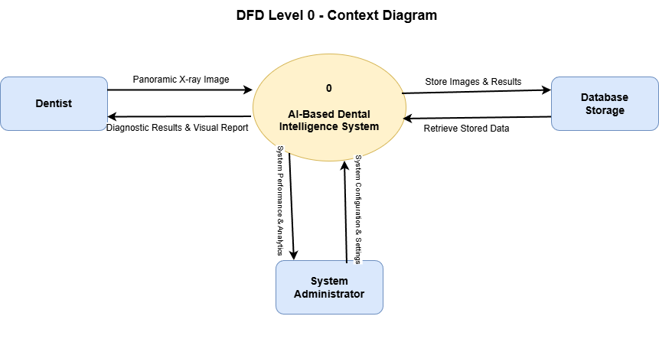
Figure 1: DFD Level 0

3.3.1.2 Level 1 DFD:

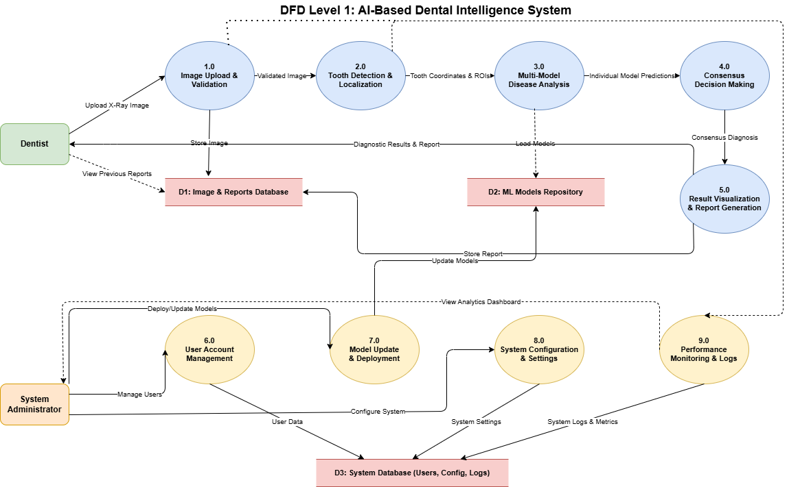
Figure 2: DFD Level 1

3.3.2 Use Case Diagrams
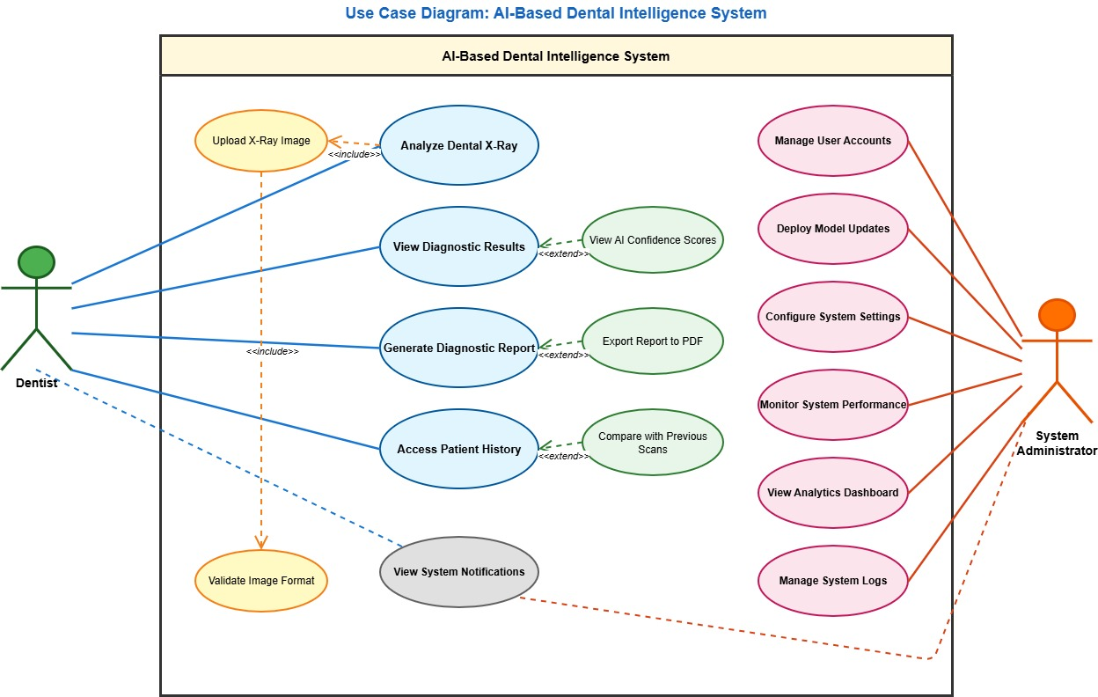
Figure 3: Use case diagrams

3.3.3 ER Diagram
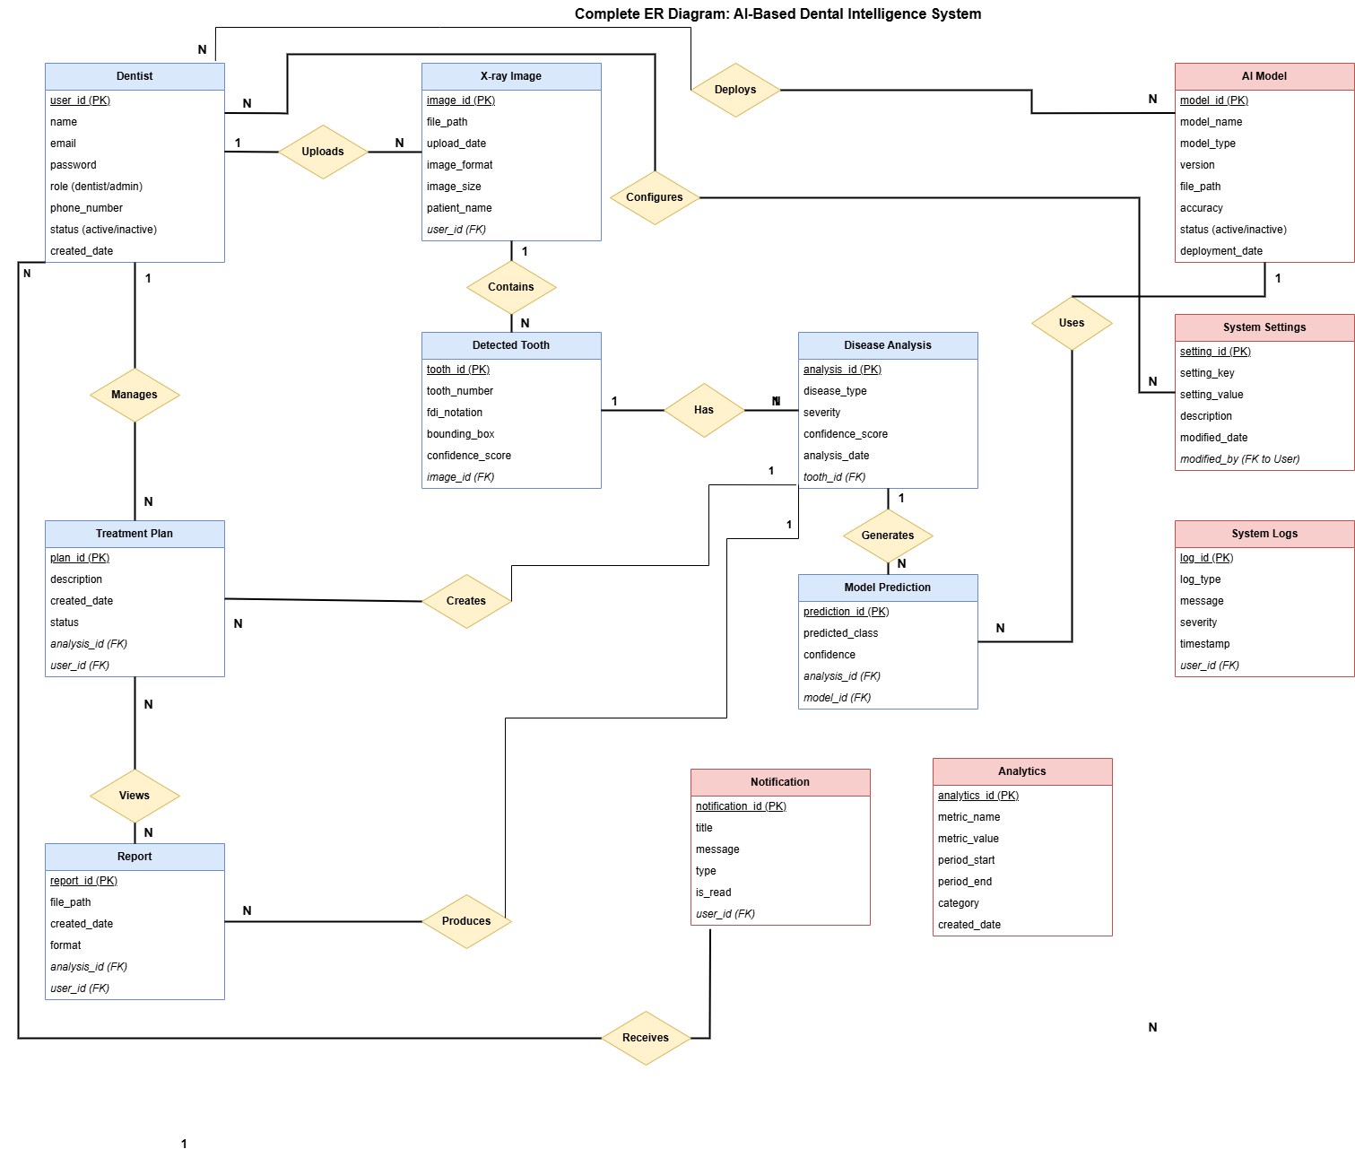
Figure 4: ER Diagram

3.3.4 Sequence and Activity Diagrams

3.3.4.1 Sequence Diagram:
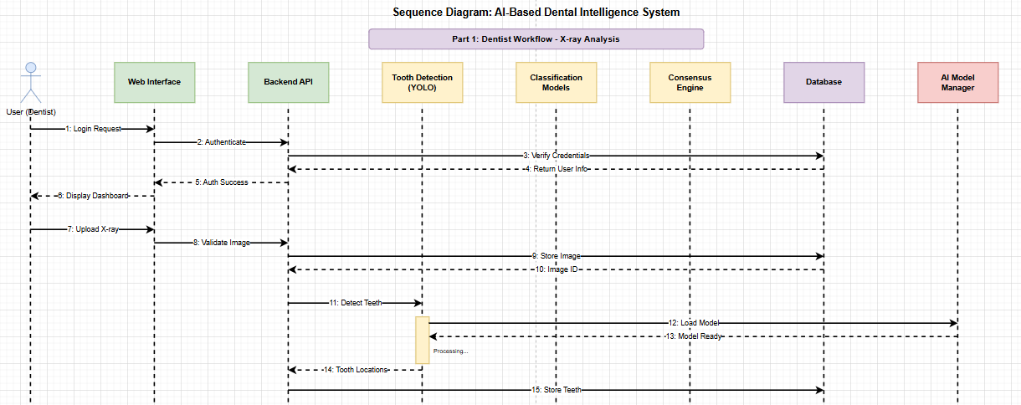
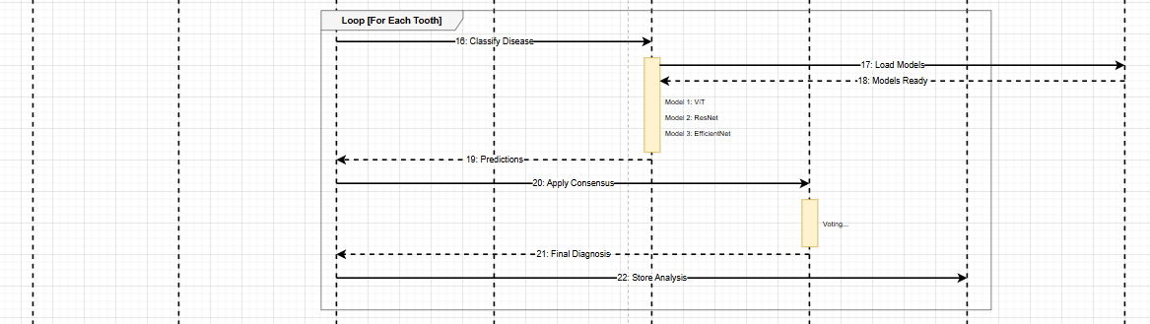
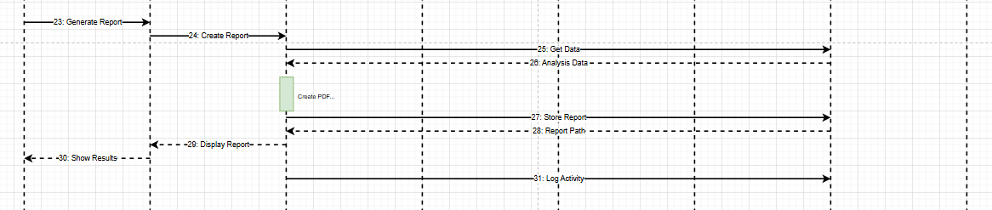
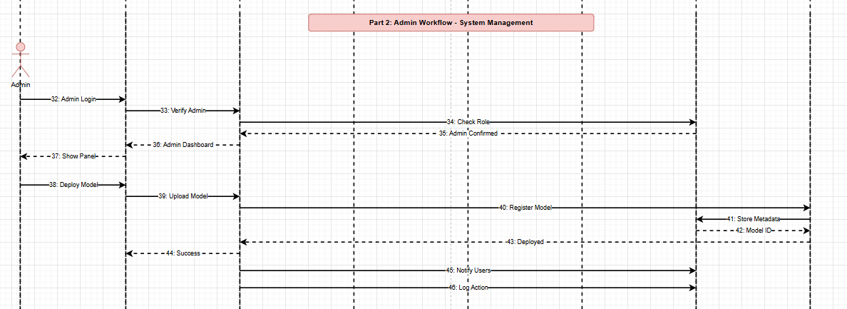
Figure 5: System Sequence Diagrams

3.3.4.2 Activity Diagram:
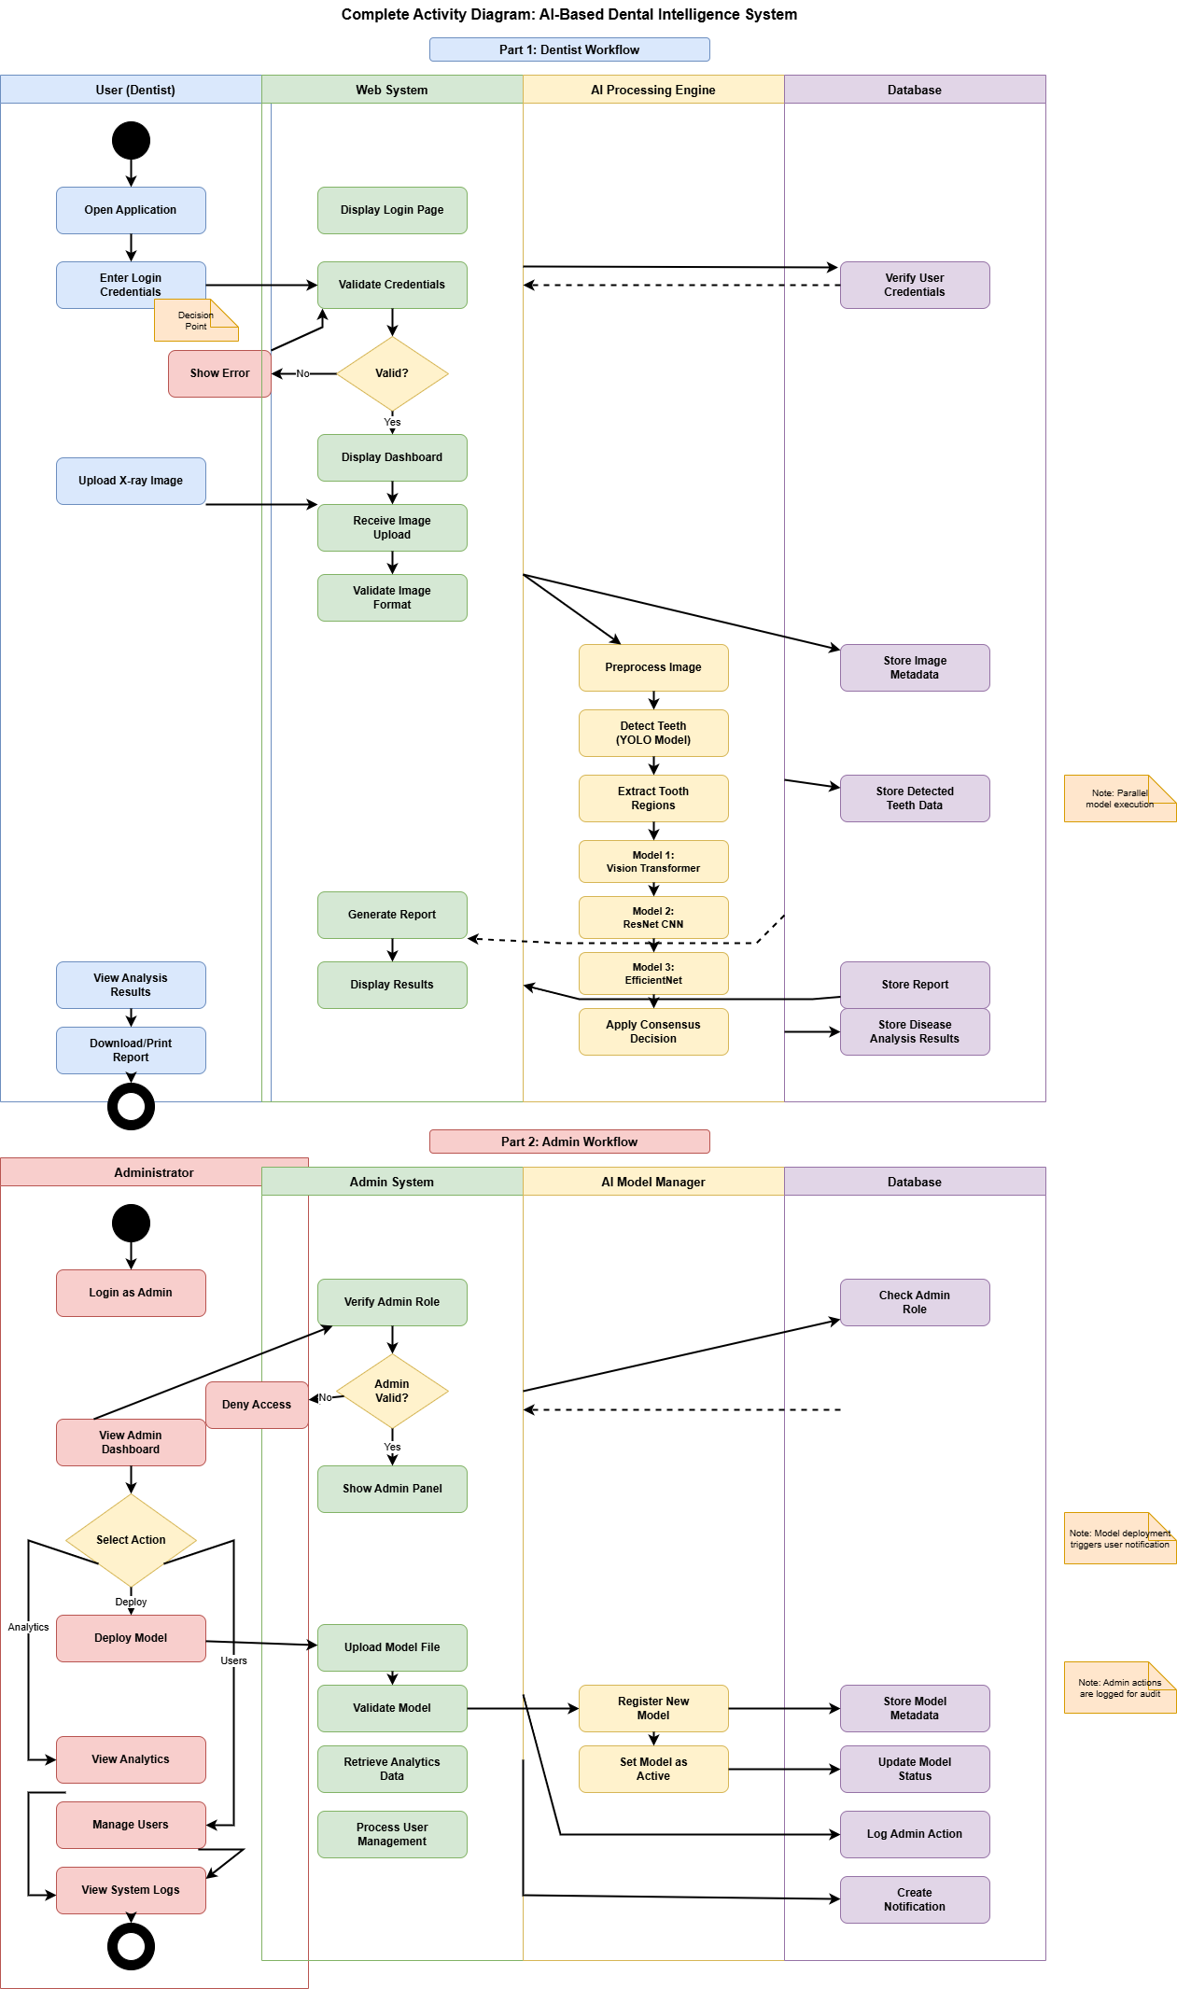
Figure 6: Activity Diagram

3.4 External Interface Requirements

3.4.1 User Interfaces
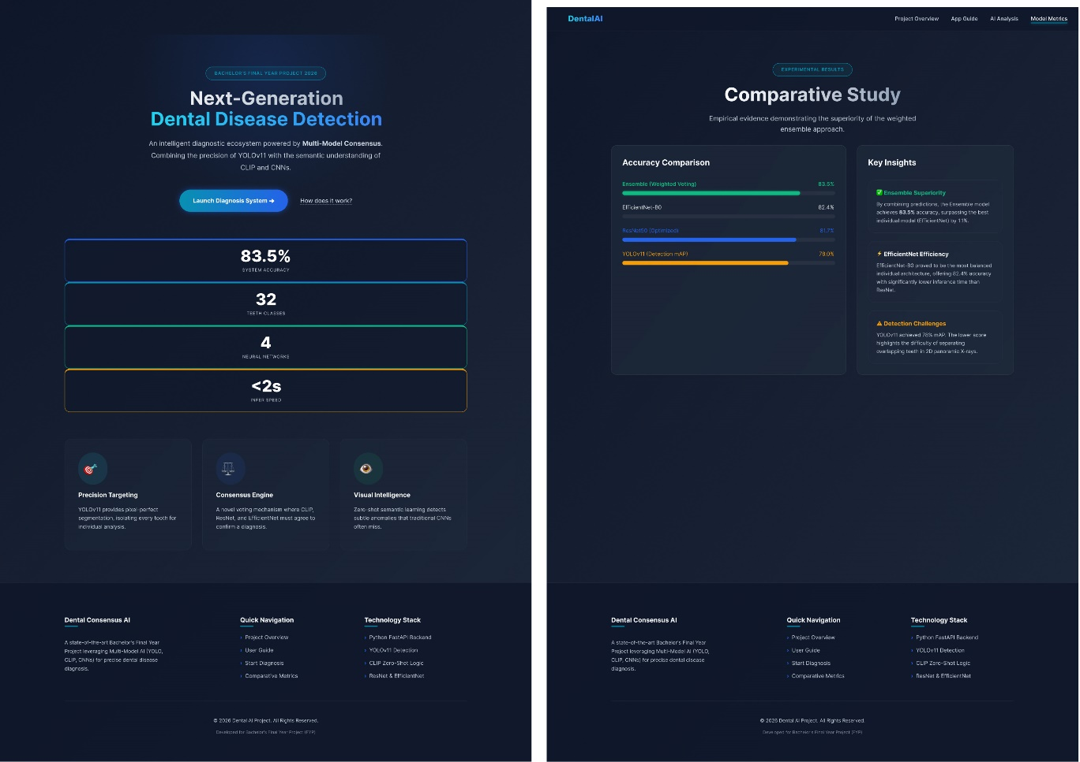
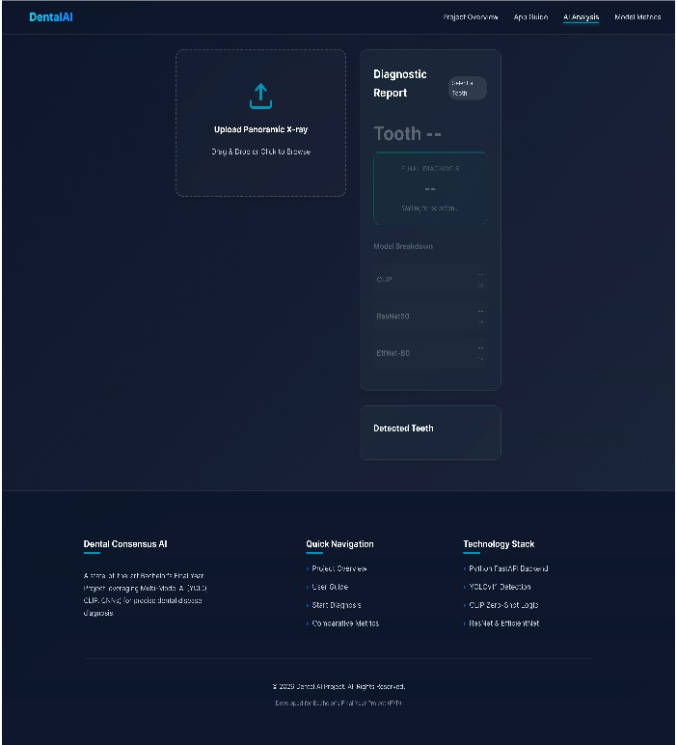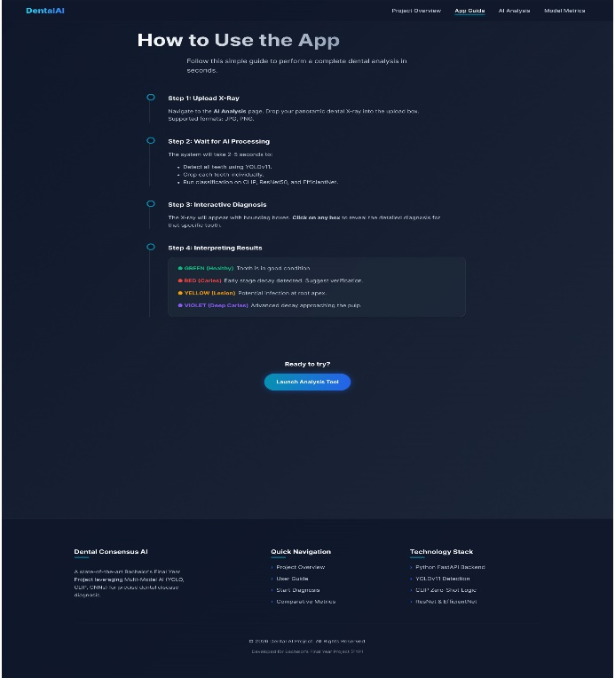
Figure 7: user interface

3.4.2 Hardware Interfaces
The system does not require specialized hardware for basic operation; however, certain hardware components enhance performance and usability.
The required and optional hardware components include:
- Client Device:
  - Desktop or laptop computer
  - Minimum 8 GB RAM
  - Internet-enabled device
- Server Hardware:
  - CPU-based server for inference
  - Optional GPU support for faster model execution
  - Minimum 16 GB RAM for stable performance
- Imaging Equipment:
  - Panoramic dental X-ray machine (external to the system)
  - Digital X-ray images provided in standard formats

3.4.3 Software Interfaces
Key software interfaces include:
- Backend Framework: Used to manage requests, model inference, and responses
- Deep Learning Libraries: Used for training and inference of classification and detection models
- Image Processing Libraries: Used for image preprocessing and enhancement
- Database System: Used to store user information, uploaded images, and diagnostic results
- Web Browser: Acts as the client-side interface for users

3.4.4 Communication Interfaces
The system uses standard communication protocols to ensure reliable and secure data exchange.
Communication characteristics include:
- Protocol: Hypertext Transfer Protocol Secure
- Data Format: JavaScript Object Notation for requests and responses
- Image Format: Standard image formats such as PNG and JPEG
- Client-Server Communication: Request-response model
All communications between the user interface and backend server are encrypted to ensure data privacy and security.

3.5 Constraints and Limitations
The development and deployment of the AI-Based Dental Intelligence System are subject to certain real-world constraints and limitations:
- Limited availability of large, fully annotated dental X-ray datasets
- Dependence on image quality for accurate diagnosis
- Computational resource limitations when running multiple deep learning models simultaneously
- Time constraints associated with academic project deadlines
- The system is intended as a decision-support tool and not a replacement for professional medical judgment

3.6 Assumptions and Dependencies
This section outlines the assumptions made during system development and the dependencies required for proper operation.
Assumptions:
- Users have basic familiarity with web-based systems
- Uploaded X-ray images are clear and properly captured
- Internet connectivity is stable during system usage
- Dental professionals will use the system as a supporting diagnostic tool
Dependencies:
- The system depends on trained deep learning models for accurate predictions
- Reliable backend server availability is required
- Performance depends on computational resources such as CPU or GPU
- System accuracy depends on the quality and diversity of training data

Chapter 4

Remaining Work and Timeline

This chapter outlines the remaining tasks required to finalize the AI-Based Dental Intelligence System. While the core system architecture, model integration, and web-based interface have already been successfully implemented, certain research and evaluation components remain necessary to strengthen the technical contribution of the project. In particular, additional deep learning models are to be trained and evaluated to enable a comprehensive comparative study, which is a key objective of this project.

4.1 Remaining Work
The following tasks are identified as outstanding before the project can be considered complete:

4.1.1 Training of Additional Deep Learning Models
Although the system currently includes trained models for dental disease detection and classification, two additional deep learning architectures will be implemented and trained. These models will be selected to provide architectural diversity and enable a fair comparison of performance across different approaches. (Status: Pending, Expected Completion: February 2026)

4.1.2 Comparative Performance Analysis
A detailed comparative study will be conducted among all implemented models. The models will be evaluated using standard performance metrics such as accuracy, precision, recall, and F1-score. This analysis will help identify strengths and weaknesses of each model and justify the selection of the final model or ensemble strategy.(Status: Pending, Expected Completion: March 2026)

4.1.3 Performance Optimization
After training and evaluation of all models, the system will be optimized to ensure efficient inference and stable performance. This includes refining model loading mechanisms, optimizing memory usage, and improving response time for real-time analysis. (Status: Pending, Expected Completion: March 2026)

4.1.4 System Testing and Validation
Comprehensive testing will be performed using unseen dental X-ray images to validate system accuracy, robustness, and consistency. This step ensures that the integrated system performs reliably under different input conditions. (Status: Pending, Expected Completion: April 2026)

4.1.5 Results Documentation and Analysis
The final experimental results, including comparative tables, graphs, and qualitative observations, will be documented in detail. This task is critical for demonstrating the effectiveness and research contribution of the project. (Status: Pending, Expected Completion: April 2026)
Table 2: Remaining Tasks
Task ID | Task Description | Status | Expected Completion
RW1 | Training of additional deep learning models | Pending | Feb 2026
RW2 | Comparative performance analysis | Pending | Mar 2026
RW3 | System performance optimization | Pending | Mar 2026
RW4 | System testing and validation | Pending | Apr 2026
RW5 | Results documentation and analysis | Pending | Apr 2026

4.3 Milestone Overview
The project is expected to reach the following milestones:
- February 2026: Fully integrated diagnostic system
- March 2026: Optimized and tested inference pipeline
- April 2026: Finalized user interface and evaluation results
- May 2026: Complete documentation and project submission
These milestones ensure a structured and manageable progression toward project completion while allowing sufficient time for testing, refinement, and documentation.

References

[1]AI Applications in Dental Caries Detection from Panoramic Imaging by Man Hung , Daniel Yevseyevich , Milan Khazana , Connor Schwartz , Martin S Lipsky https://pmc.ncbi.nlm.nih.gov/articles/PMC12385533/
[2] A comprehensive survey of deep learning algorithms and applications in dental radiograph analysis by Suvarna Bhat, Gajanan K. Birajdar, Mukesh D. Patil https://www.sciencedirect.com/science/article/pii/S2772442523001491?via%3Dihub
[3] REVOLUTIONIZING DENTAL DIAGNOSIS: A CUTTING-EDGE DEEP LEARNING APPROACH FOR DISEASE CLASSIFICATION by Muhammad Adnan Hasnain, Muhammad Ashad Baloch, Aqsa Jameel, Zaid Sarfraz, Abdul Majid Soomro, Imran Khurshid https://jptcp.com/index.php/jptcp/article/view/3299
[4] Deep Learning Models for Classification of Dental Diseases Using Orthopantomography X-ray OPG Images by Yassir Edrees Almalki , Amsa Imam Din and group members https://pmc.ncbi.nlm.nih.gov/articles/PMC9572157/
[5] S. Bhat et al., “Deep learning in dental numerical radiograph analysis: A review,” 2021.

APPENDICES

<Attach any extra information (complete code, all results etc.), references to any documents as appendices starting from next page>

